360 Assessment - Foji Dhansaw

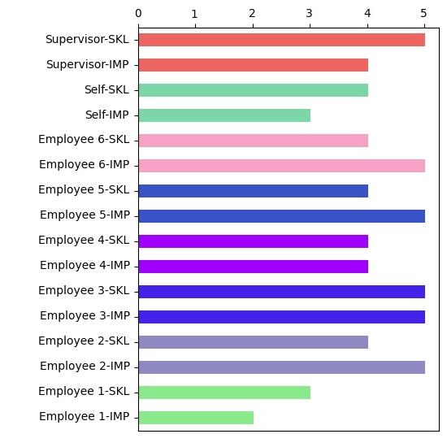

1. 𝗖𝗼𝘂𝗿𝗮𝗴𝗲 - Readily tackles tough assignments. Faces difficult issues and supports others who do the same. Provides direct and actionable feedback. Is willing to champion an idea or position despite dissent or political risk.

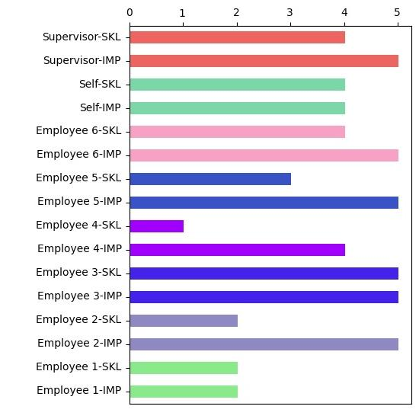

2. Instills Trust - Follows through on commitments. Is seen as direct and truthful. Keeps confidences. Practices what he/she preaches. Shows consistency between words and actions.

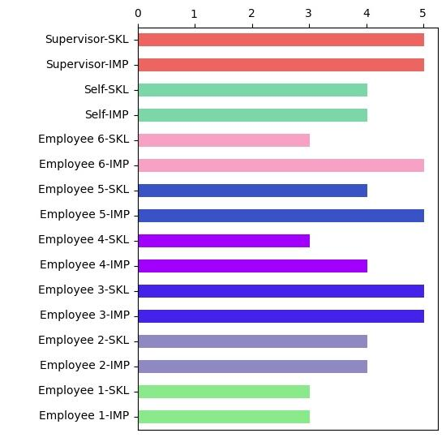

3. Manages Ambiguity - Deals comfortably with the uncertainty of change. Effectively handles risk. Can decide and act without the total picture. Is calm and productive, even when things are up in the air. Deals constructively with problems that do not have clear solutions or outcomes.

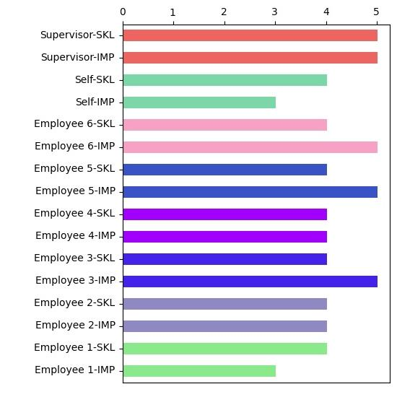

4. Nimble Learning - Learns quickly when facing new situations. Experiments to find new solutions. Takes on the challenge of unfamiliar tasks. Extracts lessons learned from failures and mistakes

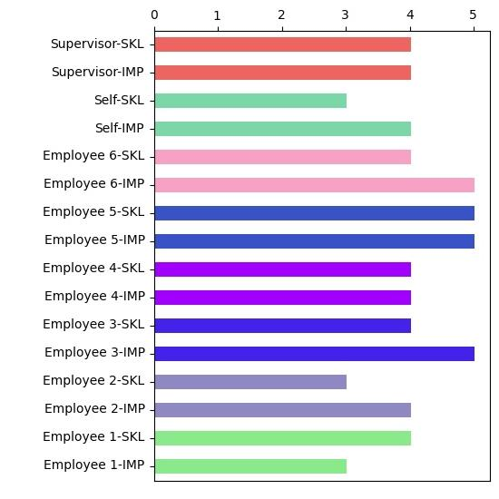

5. Being Resilient - Is confident under pressure. Handles and manages crisis effectively. Maintains a positive attitude despite adversity. Bounces back from setbacks. Grows from hardships and negative experiences.

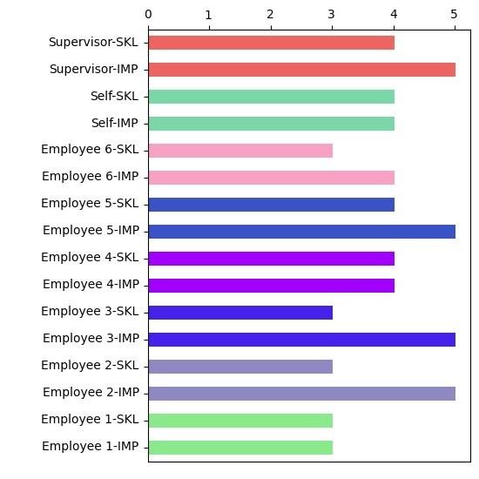

6. Situational Awareness - Picks up on situational cues and adjusts in the moment. Readily adapts personal, interpersonal, and leadership behaviour. Understands the different situations may call for different approaches. Can act differently depending on the circumstances

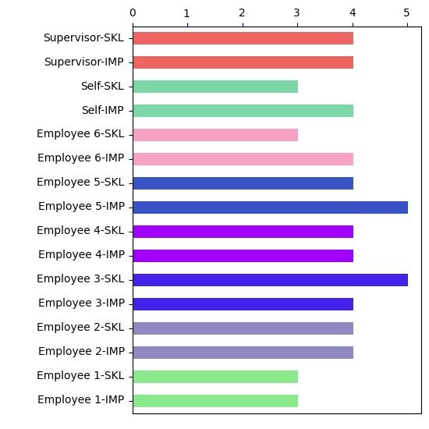

7. Self-Development - Shows personal commitment and takes action to continuously improve. Accepts assignments that broaden capabilities. Learns from new experiences, from others, and from structured learning. Makes the most of available development resources.

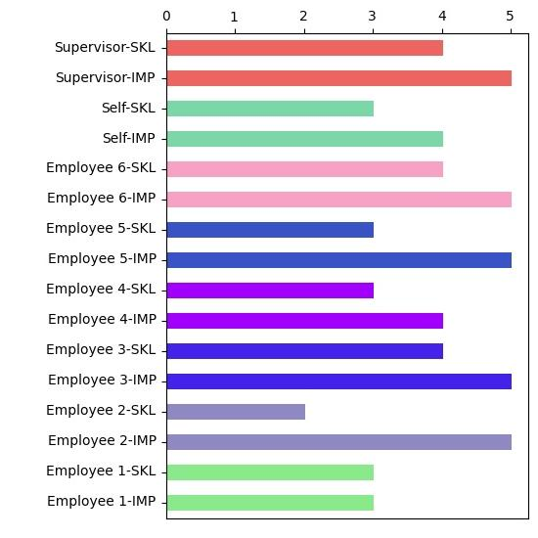

8. Self-Awareness - Reflects on activities and impact on others. Proactively seeks feedback without being defensive. Is open to criticism and talking about shortcomings. Admits mistakes and gains insight from experiences. Knows strengths, weaknesses, opportunities, and limits.

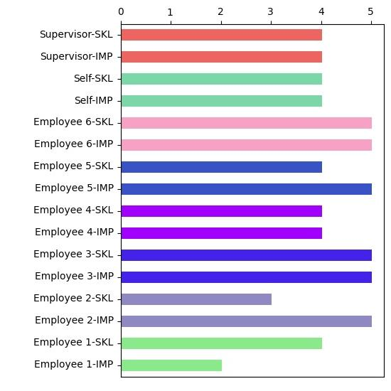

9. Communicates Effectively - Is effective in a variety of communication settings: one-on-one, small, and large groups, or among diverse styles and position levels. Attentively listens to others. Adjusts to fit the audience and the message. Provides timely and helpful information to others across the organization. Encourages the open expression of diverse ideas and opinions.

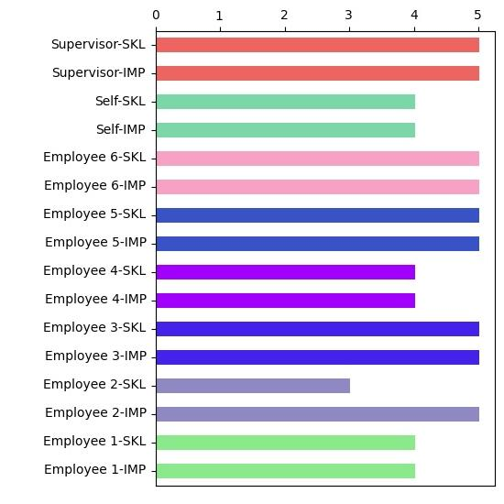

10. Drives Engagement - Structures the work so it aligns with people’s goals and motivators. Empowers others. Makes each person feel his/her contributions are important. Invites input and shares ownership and visibility. Shows a clear connection between people’s motivations and organizational goals.

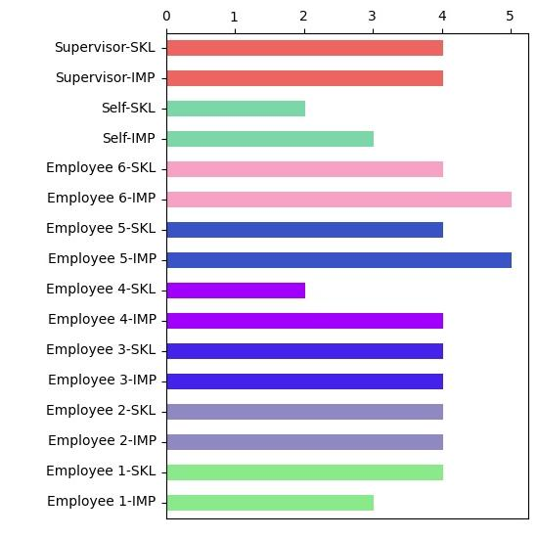

11. Organizational Savvy - Anticipates the impact of emerging technologies and makes adjustments. Scans the environment for new technical skills, knowledge, or capabilities that can benefit business or personal performance. Rejects low-impact or fad technologies. Readily learns and adopts new technologies.

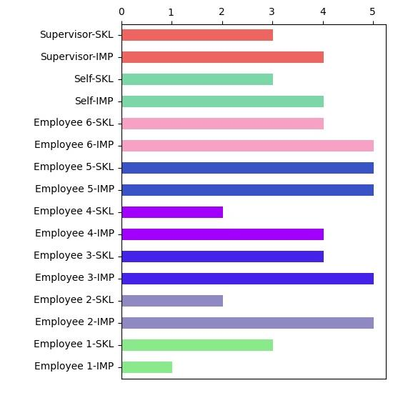

12. Persuades - Positions views and arguments appropriately to win support. Convinces others to take action. Negotiates skillfully in tough situations. Wins concessions without damaging relationships. Responds effectively to the reactions and positions of others.

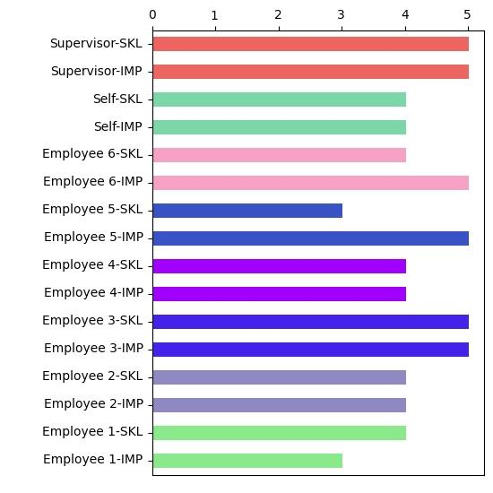

13. Drives Vision and Purpose - Talks about the future possibilities in a positive way. Creates milestones and symbols to rally support behind the vision. Articulates the vision in a way everyone can relate to. Creates organization-wide energy and optimism for the future. Shows personal commitment to the vision

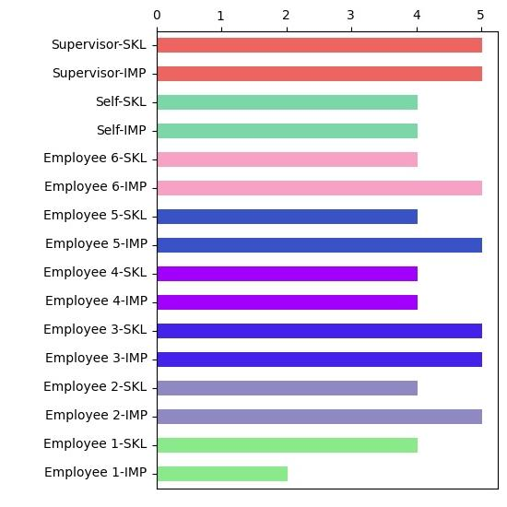

14. Attracts Top Talent - Attracts and selects diverse and high caliber talent. Finds the right talent to meet the group’s needs. Closes talent gap with the right balance of internal and external candidates. Is a good judge of talent.

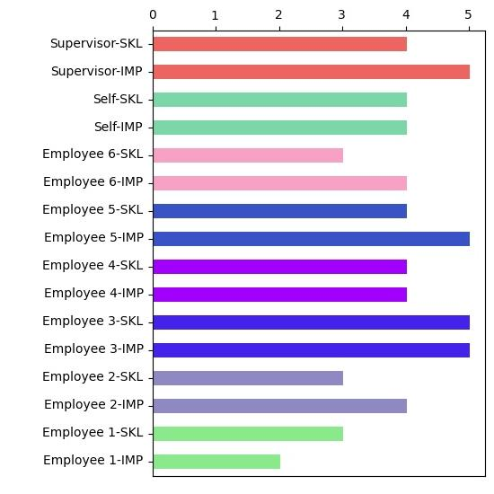

15. Develops Talent - Places a high priority on developing others. Develops others through coaching, feedback, exposure, and stretch assignments. Aligns employee career development goals with organizational objectives. Encourages people to accept developmental moves.

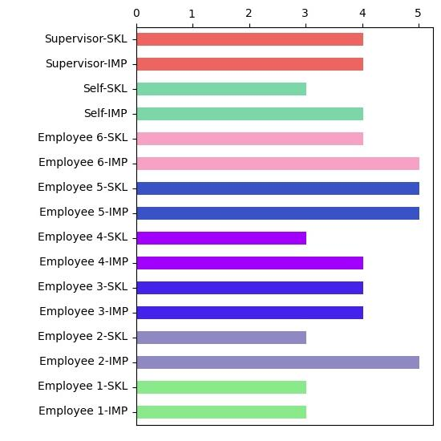

16. Values Differences - Seeks to understand different perspectives and cultures. Contributes to a work climate where differences are valued and supported. Applies others’ diverse experiences, styles, backgrounds, and perspectives to get results. Is sensitive to cultural norms, expectations, and ways of communicating.

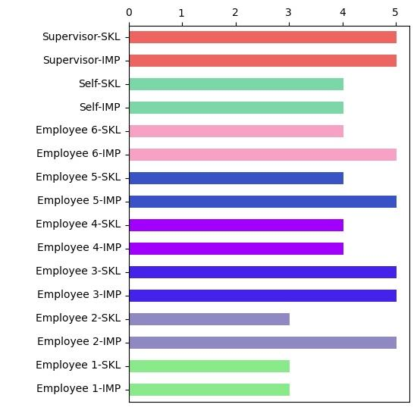

17. Builds Effective Teams - Forms teams with appropriate and diverse mix of styles, perspectives, and experiences. Establishes common objectives and a shared mindset. Creates a feeling of belonging and strong team morale. Shares wins and rewards team efforts. Fosters open dialogue and collaboration among the team.

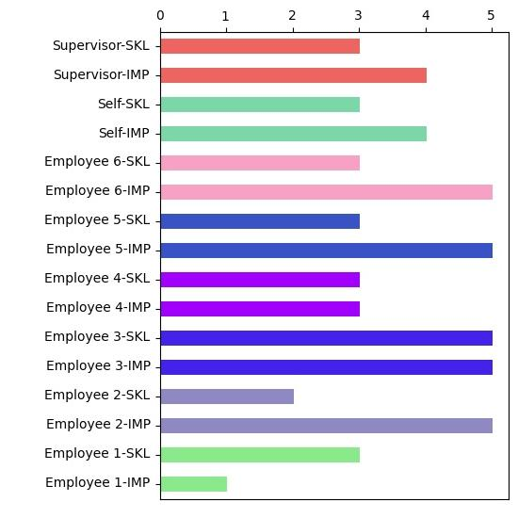

18. Collaborates - Works cooperatively with others across the organization to achieve shared objectives. Represent own business interests while being fair to others and their areas. Partners with others to get work done. Credits others for their contributions and accomplishments. Gains trust and support of others.

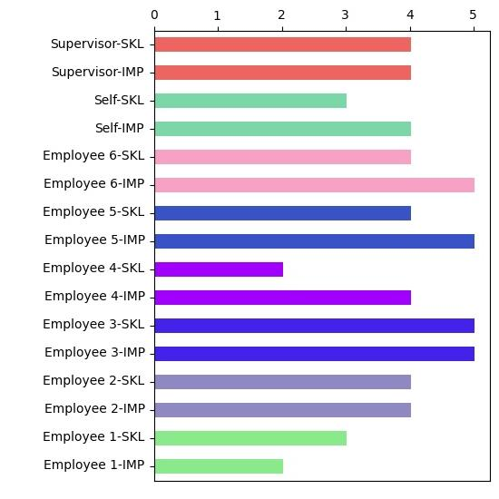

19. Manages Conflict - Steps up to conflicts, seeing them as opportunities. Works out tough agreements and settles disputes equitably. Facilitates breakthroughs by integrating diverse views and finding common ground or acceptable alternatives. Settles differences in productive ways with minimum noise.

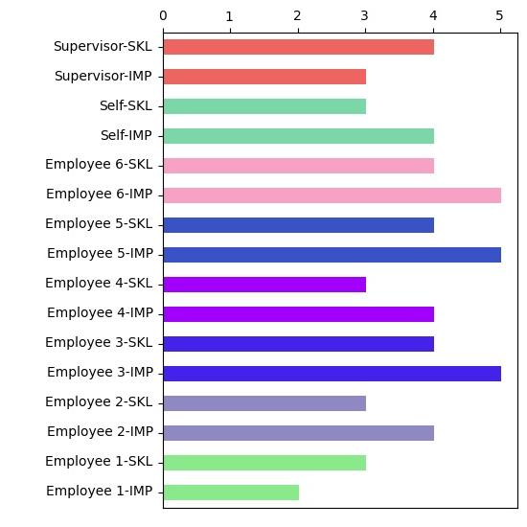

20. Interpersonal Savvy - Relates comfortably with people across levels, functions, cultures, and geography. Act with diplomacy and tact. Builds constructive relationships with people both similar and different to self. Picks up on interpersonal and group dynamics.

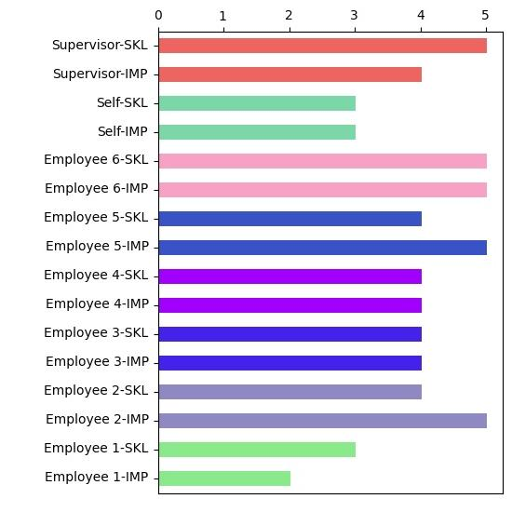

21. Builds Networks - Builds strong formal and informal networks. Maintains relationships across a variety of functions and locations. Draws upon multiple relationships to exchange ideas, resources, and know-how.

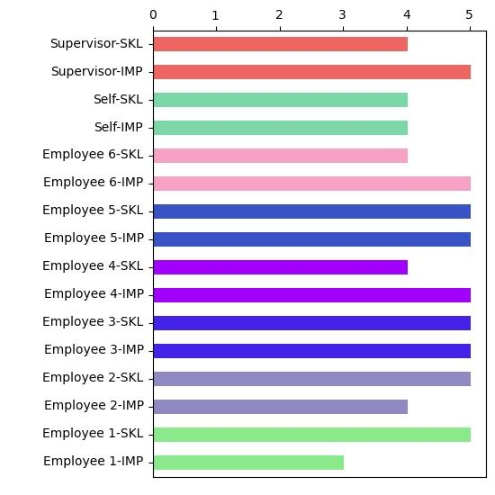

22. Business Insight - Knows how businesses work and how organizations make money. Keeps up with current and possible future policies, practices, and trends in the organization, with the competition, and in the marketplace. Uses knowledge of business drivers and how strategies and tactics play out in the market to guide actions.

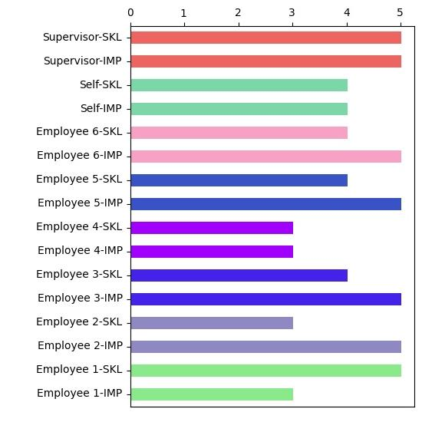

23. Customer Focus - Gains insight into customer needs. Identifies opportunities that benefit the customer. Builds and delivers solutions that meet customer expectations. Establishes and maintains effective customer relationships.

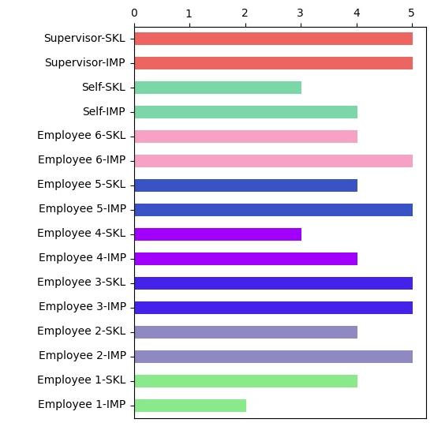

24. Financial Acumen - Understands the meaning and implications of key financial indicators. Uses financial analysis to generate, evaluate and act on strategic options and opportunities. Integrates quantitative and qualitative information to draw accurate conclusions.

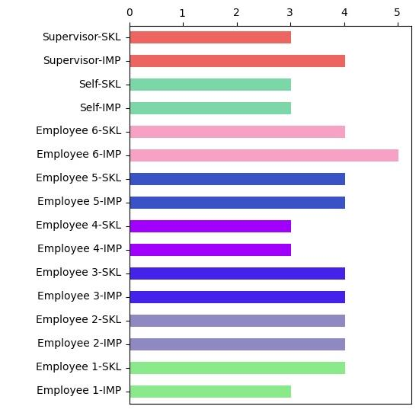

25. Tech Savvy - Anticipates the impact of emerging technologies and makes adjustments. Scans the environment for new technical skills, knowledge, or capabilities that can benefit business or personal performance. Rejects low-impact or fad technologies. Readily learns and adopts new technologies.

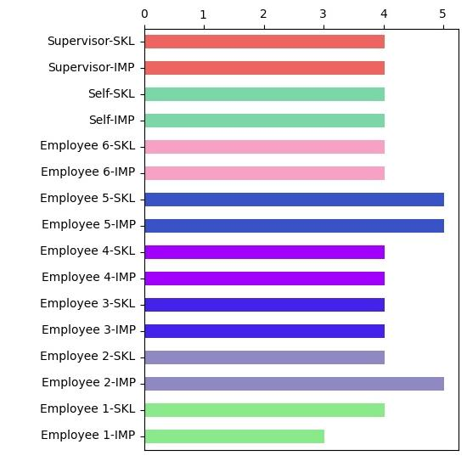

26. Manages Complexity - Asks the right questions to accurately analyze situations. Acquires data from multiple and diverse sources when solving problems. Uncovers root causes to difficult problems. Evaluates pros and cons, risk, and benefits of different solution options.

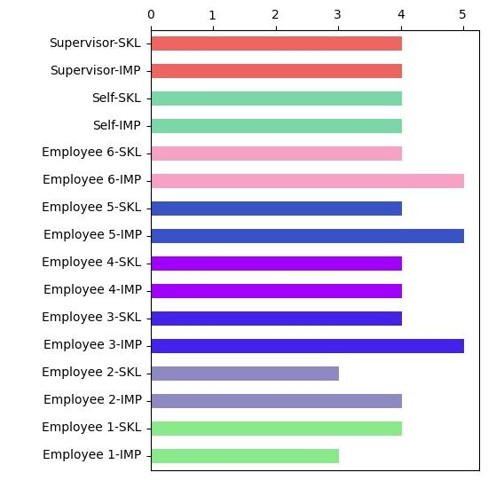

27. Decision Quality - Makes sound decisions, even in the absence of complete information. Relies on a mixture of analysis, wisdom, experience, and judgement when making decisions. Considers all relevant factors and uses appropriate decision-making criteria and principles. Recognizes when a quick 80% solution will suffice.

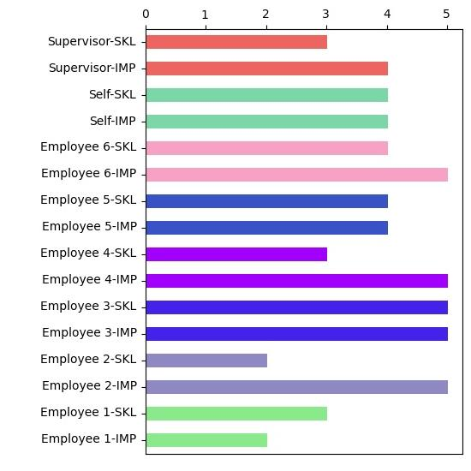

28. Balances Stakeholders - Understands internal and external stakeholder requirements, expectations, and needs. Balances the interests of multiple stakeholders. Considers cultural and ethical factors in the decision-making process. Acts fairly despite conflicting demands of stakeholders.

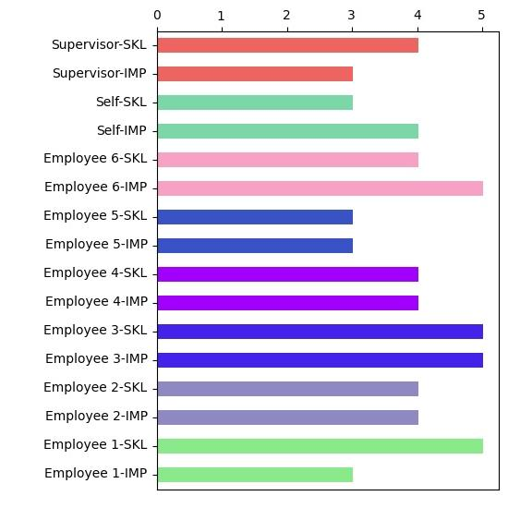

29. Global Perspective - Looks toward the broadest possible view of an issue or challenge. Thinks and talks in global terms. Understands the position of the organization within a global context. Knows the impact of global trends on the organization.

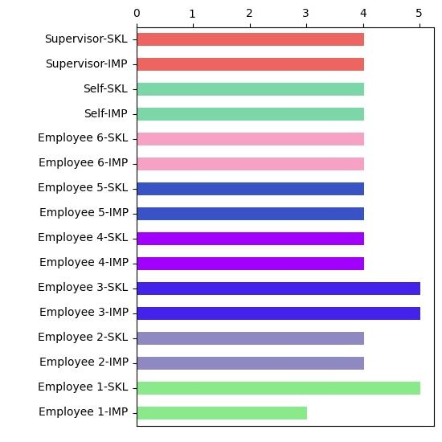

30. Cultivates Innovation - Comes up with useful ideas that are new, better, or unique. Introduces new ways of looking at problems. Can take a creative idea and put it into practice. Encourages diverse thinking to promote and nurture innovation.

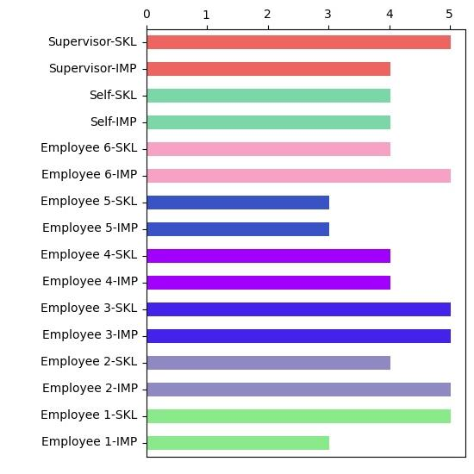

31. Strategic Mindset - Anticipates future trends and implications accurately. Readily poses future scenarios. Articulates credible pictures and visions of possibilities that will create sustainable value. Creates competitive and breakthrough strategies that show a clear connection between vision and action.

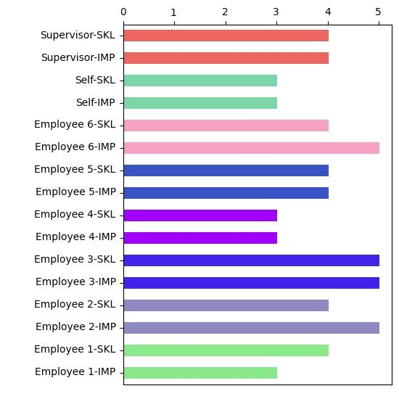

32. Resourcefulness - Marshals resources (people, funding, material, support) to get things done. Orchestrates multiple activities simultaneously to accomplish a goal. Gets the most out of limited resources. Applies knowledge of internal structures, processes, and culture to resourcing efforts.

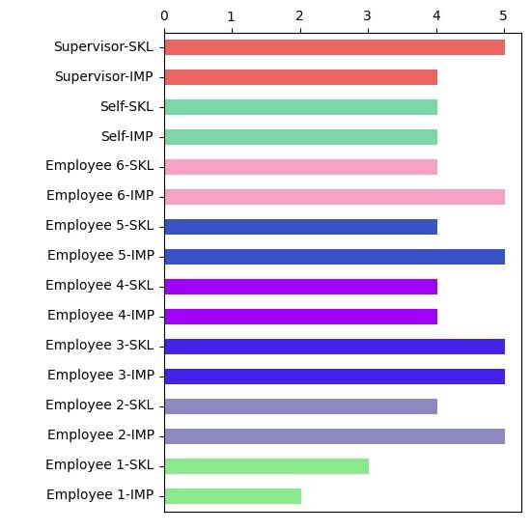

33. Action Oriented - Readily takes action on challenges, without unnecessary planning. Identifies and seizes new opportunities. Displays a can-do attitude in good and bad times. Steps up to handle tough issues.

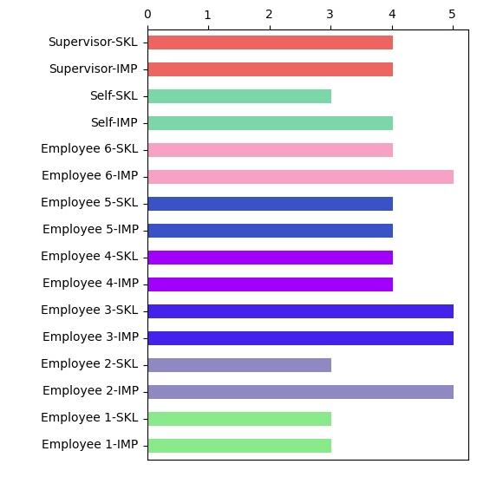

34. Direct Work - Provides clear direction and accountabilities. Delegates and distributes assignments and decisions appropriately. Monitors progress by maintaining dialogue on work and results. Provides appropriate guidance and direction based on people’s capabilities. Intervenes as needed to remove obstacles.

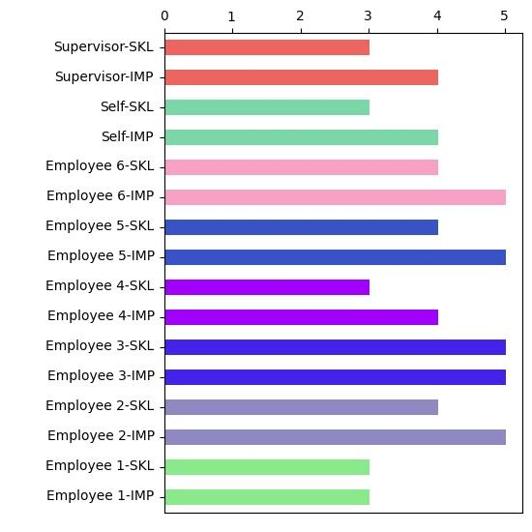

35. Plans and Aligns - Sets objectives to align with broader organizational goals. Breaks down objectives into appropriate initiatives and actions. Stages activities with relevant milestones and schedules. Anticipates and adjusts effective contingency plans.

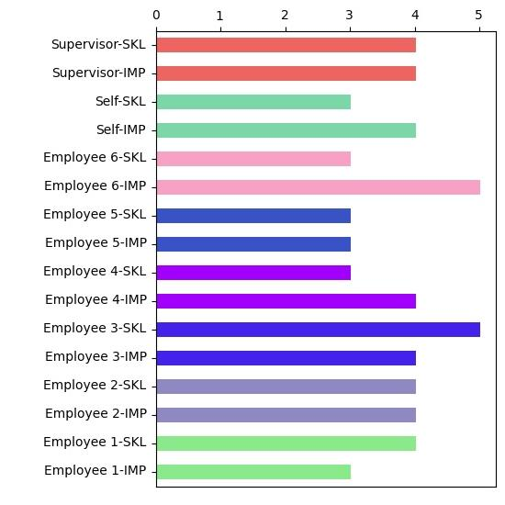

36. Optimizes Work Processes - Identifies and creates the processes necessary to get work done. Separates and combines activities into efficient workflow. Designs processes and procedures that allow managing from a distance. Seeks ways to improve processes, from small tweaks to complete reengineering.

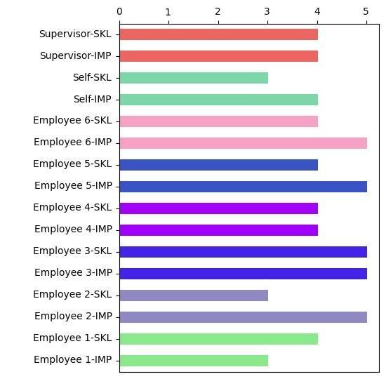

37. Ensures Accountability - Follows through on commitments and makes sure others do the same. Acts with a clear sense of ownership. Takes personal responsibility for decisions, actions, and failures. Establishes clear responsibilities and processes for monitoring work and measuring results. Designs feedback loops into work.

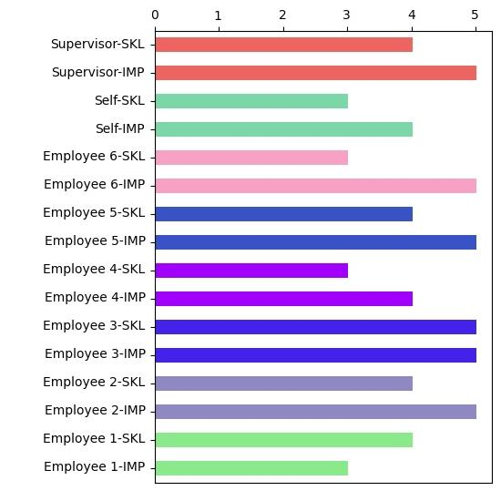

38. Drives Results - Has a strong bottom-line orientation. Persists in accomplishing objectives despite obstacles and setbacks. Has a track record of exceeding goals successfully. Pushes self and helps others achieve results.